Who should be designated as the administrator?
Preferably a technology coordinator or curriculum director at either the school or district level. Administrator responsibilities include creating teacher accounts and courses, uploading student information, maintaining course rosters, and organizing app access on school devices. You will most likely need to access roster reports to make these tasks easy.
Getting Started
There are four important steps in the onboarding process –
- creating users
- creating courses
- enrolling users
- distributing user information.

These steps are completed in the Copia back office: https://bfw.thecopia.com/back-office. You will need the username provided to you in your welcome email to access this site.
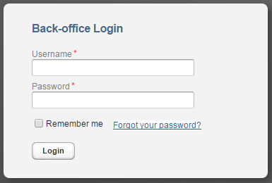

You will need multiple .csv files to bulk upload users. You can find more detail on each one in the full administrator guide, but here are the header rows for each file for future reference.
CSV Files Needed
- Create Users (header rows) – First Name, Last Name, Email Address, Username, Password, Role
- Creating Courses (header rows) – Course Name, Session Name, Term
- Enrolling Users (header rows) – Course Name, Session Name, Term, Username, Role, Status

- Creating Users
  - This is uploading all of your students and teachers into the Copia Class system.
  - To create an individual account, click manage > users > create. Complete the required fields and click save.
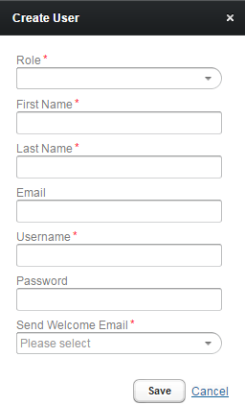
    - NOTE: Usernames must be unique within the entire Copia system. Passwords must be at least 6 characters.
    - Always select Don’t Send for the “Send Welcome Email” option
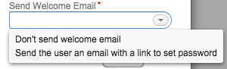
    - Recommendations
      - Use email addresses for usernames, if possible.
      - Unless a password is easily remembered, use a generic one for all students, such as 123456.

  - To create multiple accounts, click import users to upload a .csv file.
    - The header row of your .csv file must match the sample below exactly. If you get an error message, be sure your headers match the below image and there are no extra spaces or characters.
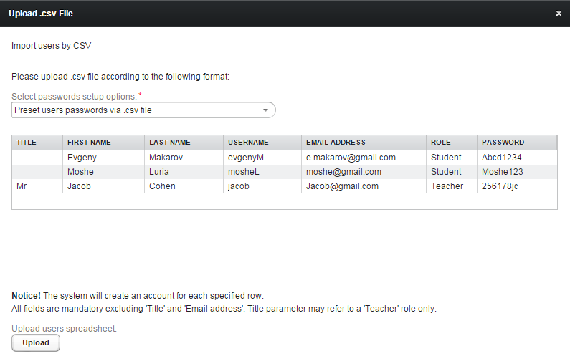

    - For the “Select Passwords Setup Option” ALWAYS select “Preset users passwords via .csv file”
    - Recommendations
      - Use email addresses for usernames, if possible.
      - Unless a password is easily available, use a generic one for all students, such as 123456.

- Creating Courses
  - Creating courses organizes or groups students and teachers into courses and allows you to give them access to books.
  - You can set up courses for every teacher and each of their class periods, however it is recommended you just create 1 course for each teacher per subject they teach.
  - To create an individual course, click manage > course sessions/classes > create.
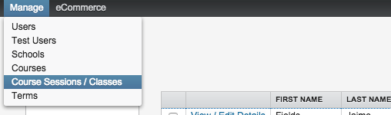
  - Complete the required fields and click save.
    - Recommendations
      - Course Name – subject
        - AP Lang, AP Stats, Psychology, APUSH, etc.
      - Session/Class Name – teacher name
        - Mr. Smith, Mrs. Williams
        - You can be as detailed as you’d like, i.e. Williams Period 2, Williams Period 5
    - NOTE: To properly assign a teacher to a course, the instructor’s username must be entered as it is in the Copia system.
  - To create multiple courses, click import sessions to upload a .csv file.
  - NOTE: All fields in the .csv file must match those in the popup.
    - Recommendations
      - Course Name – subject
        - AP Lang, AP Stats, Psychology, APUSH, etc.
      - Session/Class Name – teacher name
        - Mr. Smith, Mrs. Williams
        - You can be as detailed as you’d like, i.e. Williams Period 2, Williams Period 5
    - NOTE: To properly assign a teacher to a course, the instructor’s username must be entered completely.
  - IMPORTANT: After you have created courses, you still have to add a book(s) to the course so that members will see a book. To add a textbook to a course, click view/edit details > library > add book. Search the book by title, click on the book you would like to add to the course, and click add book.
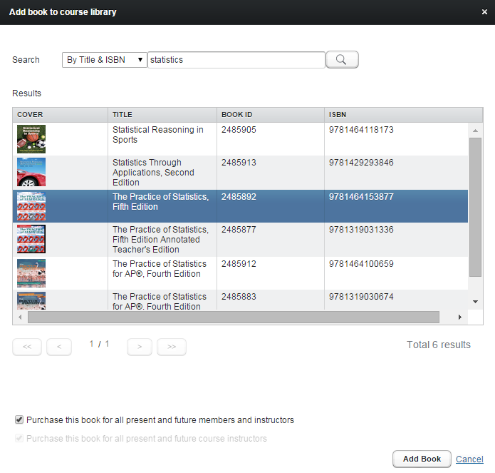
    - NOTE: ‘Purchase this book for all present and future members and instructors’ must be checked. You are not signing up for additional purchases, but ensuring that any members you add throughout the year will automatically have access to the book(s).

- Enrolling Users
  - Now you have created users and courses, so the next step is adding users to courses.
  - To enroll multiple students in a course, click manage > course sessions/classes > import enrollments and upload a .csv file.
    - NOTE: All fields in the .csv file must match those in the popup. 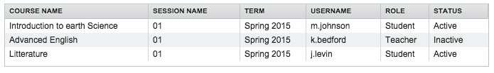
    - Course Name, Session Name, and Term are what you created for the classes in the previous step. Username is the username in Copia.

- Distributing User Information
  - To get students and teachers started using edaptext, provide them with their username, password, and the edaptext student quick start guide.
  - Copia is an app-based eReader, therefore users will need to access an app. Does your district allow users to download files from the internet? If so, follow these steps
    - Go here - https://bfw.thecopia.com
    - Enter login info, click orange login button
    - Accept terms and conditions (only do this once)
    - Once in, click eReaders (top right)
    - Download the Copia app based on the correct device you are on
    - Open the downloaded file to install the app
    - Once installed, open the app(program)
    - Login with same login info
  - If your school/district does not allow students/teachers to download files from the internet, you will need to inform your technology department that the Copia Class app needs to be “pushed” or downloaded onto all devices. They will need access to the app and can find the direct download links here –
    - PC App – http://edu.thecopia.com/rest/api/download/anonymous/PC?tenantName=Copia
    - App Store (iPad, iPhones) – https://itunes.apple.com/us/app/copia-class/id903009715?mt=8
    - Android Store – https://play.google.com/store/apps/details?id=com.comm.it.copia
    - Mac - http://edu.thecopia.com/rest/api/download/anonymous/MAC?tenantName=Copia
  - NOTE: Teachers and students can download/use their books on up to 4 devices. If students do not have permission to download apps/programs on school provided devices, school administrators will have to do so before users can access their content.

